EC2s (count reduced as few are terminated)
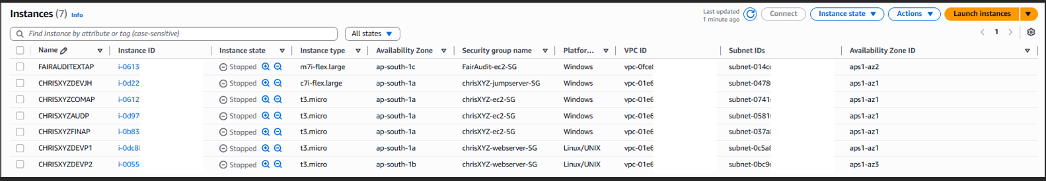
ALB

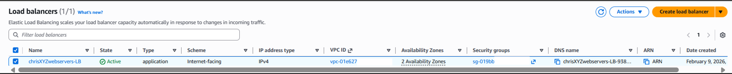
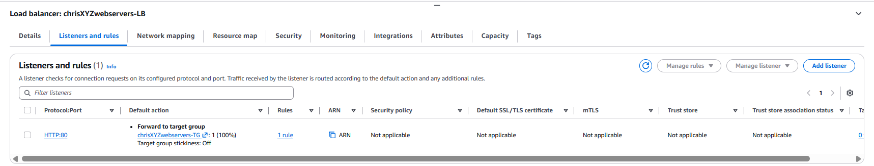
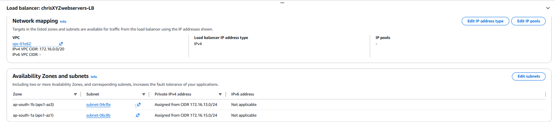
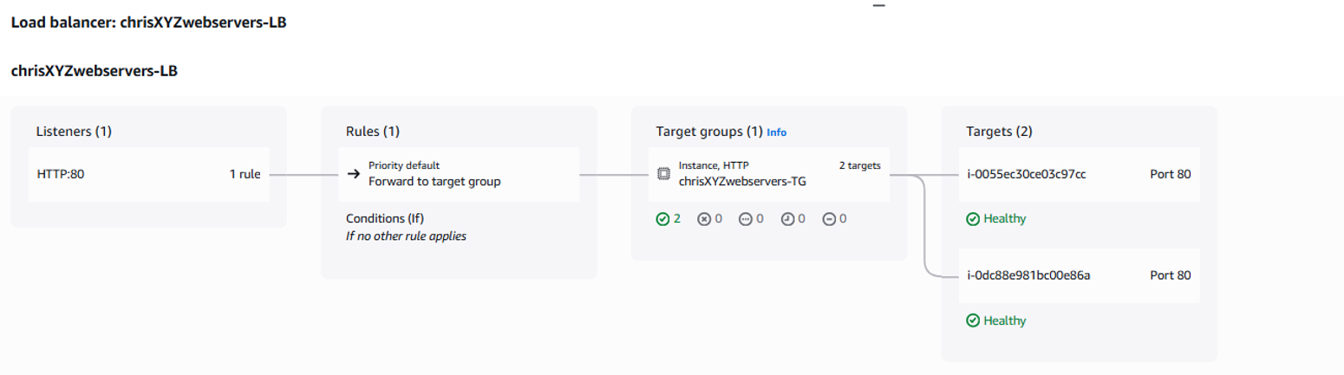
Target Group
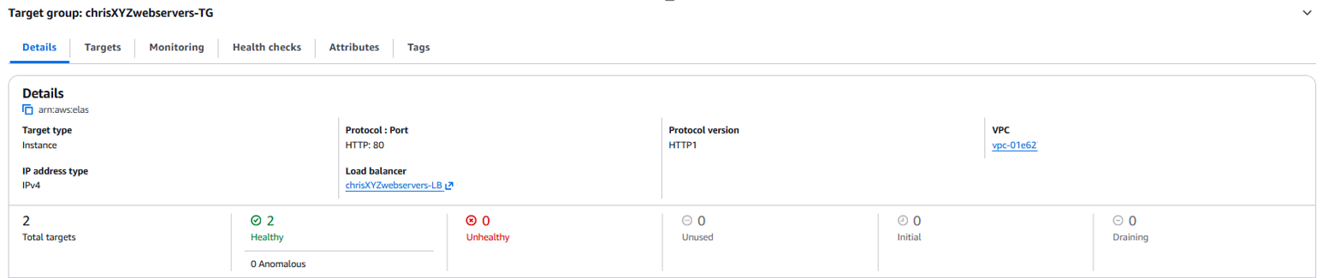

ASG
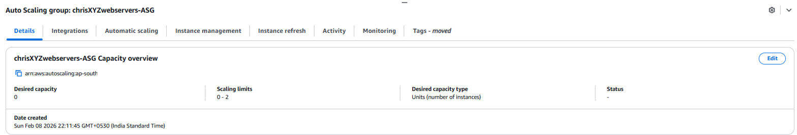
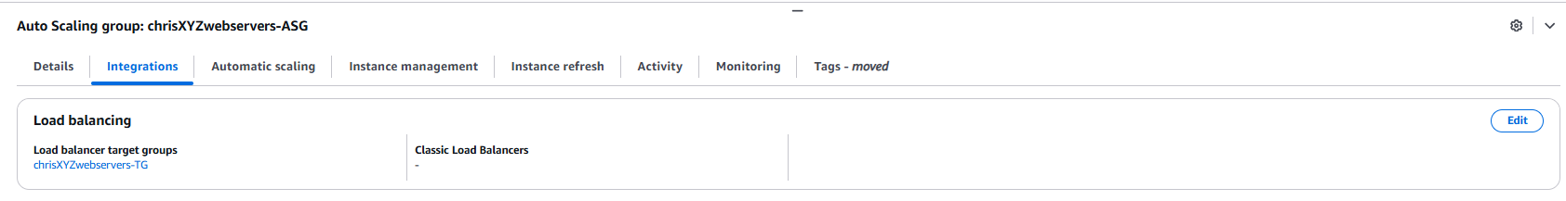
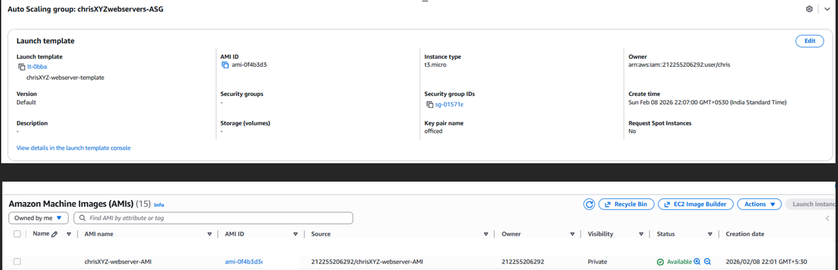

Accessing Company Website with ALB url (notice heading changed based on traffic sent to which webServer
